Name:…………………………………….
Class:………………………………………
ENGLISH GRADE 2 WORKSHEET – REVISION 6
I. Circle correct word
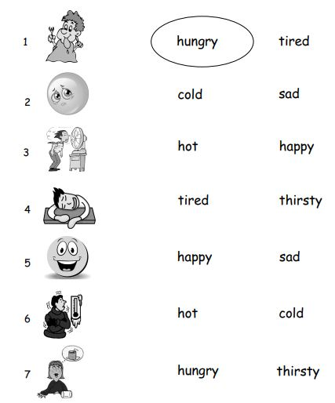
II. Find and circle.
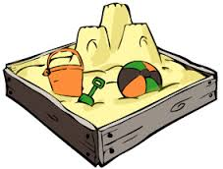
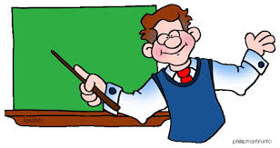
h o t t e a c h e r r e a d
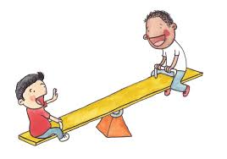
s h o r t s a n d b o x o a y d
k i s s e e s a w s a d f g h
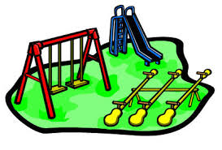
g r a n d p l a y g r o u n d d
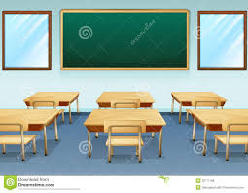
s i c l a s s r o o m o m
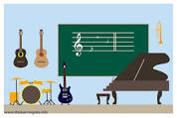
n w m u s i c r o o m e n a

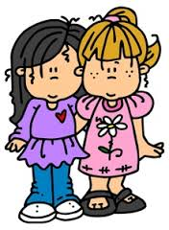
l e f r i e n d a t e

III. Look. Read then match.
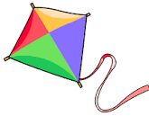
3
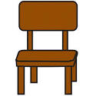
- How many kites ?
5
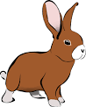
- How many chairs ?
4
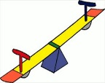
- How many rabbits ?
3
- How many seesaws ?

