Name:…………………………………….
Class:………………………………………
ENGLISH GRADE 2 WORKSHEET – REVISION 5

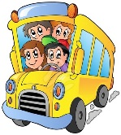
I. Find and circle
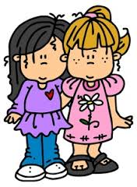
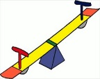

classroom
friend
schoolbus
seesaw

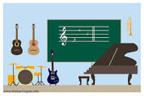
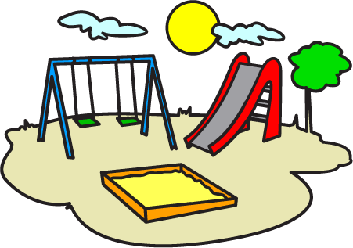

sandbox
music room
teacher
playground

a | n | b | m | i | o | t | h | o | a | k | i | m | s | f | v
c | o | d | s | i | x | t | e | t | r | b | a | s | a | s | g
g | q | s | d | s | e | e | s | a | w | r | o | a | n | g | h
y | m | g | t | p | l | a | y | g | r | o | u | n | d | k | i
t | u | b | a | g | h | c | s | c | h | o | o | l | b | u | s
o | s | m | k | m | i | h | w | q | y | t | l | c | o | i | o
e | i | d | n | d | l | e | a | r | j | b | c | r | x | l | m
h | c | l | a | s | s | r | o | o | m | w | l | o | e | u | u
f | r | i | e | n | d | b | y | c | e | j | m | u | t | o | b
e | o | v | r | a | c | w | u | r | b | q | g | w | j | p | i
m | o | o | d | v | j | e | b | l | w | h | t | k | h | l | a
i | m | t | w | o | c | l | h | t | c | o | b | l | o | q | r

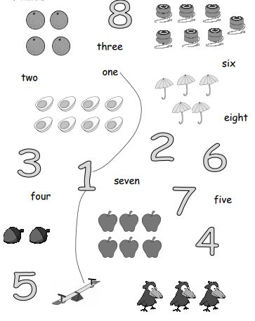
II. Match

III. Trace and write.
…………………….
…………………….
…………………….
…………………….
…………………….
…………………….
…………………….
…………………….
…………………….
…………………….

