Name:…………………………………….
Class:………………………………………
ENGLISH GRADE 2 WORKSHEET – REVISION 4
I. Write the letters in order
Jj
Ff
Dd
Aa

Hhh
Ll

Zz
Ww

Rs
Pp

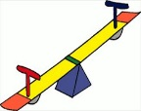
II. Number
b.
c.
a.
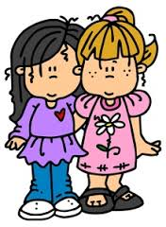
1. teacher
2. school bus .
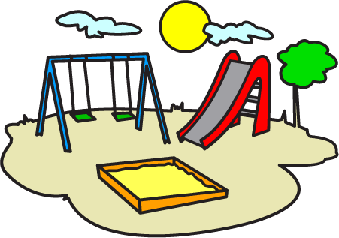
3. friend
f.
4. seesaw
5. music room
d.
6. playground
e.
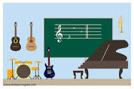
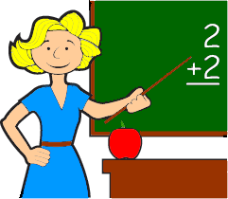
7. classroom
g.
8. sandbox
h.

III. Write and match
It’s a school bus.
1. What’s this?

___________ music room.
2. . Who’s this?

She’s my friend.
3. _________ this?

________________ teacher.
4. _________ this?

___________ music room.
5. _________ this?

