Name:…………………………………….
Class:………………………………………
ENGLISH GRADE 2 WORKSHEET – REVISION 3

I. Circle the correct word.
onMady
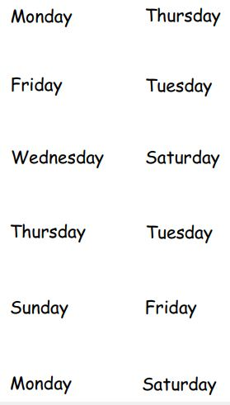
1.

edsTuay
2.

3.
ytruadSa

udsTrahy
4.

ardiFy
5.

udartyaS
6.

II. Colour the picture and write the letter
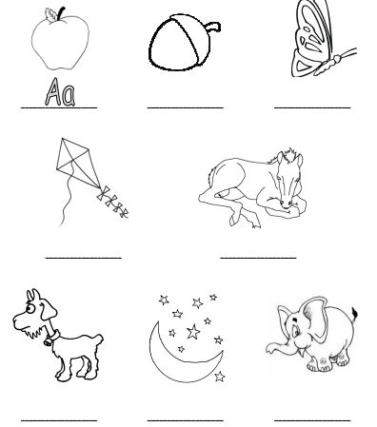

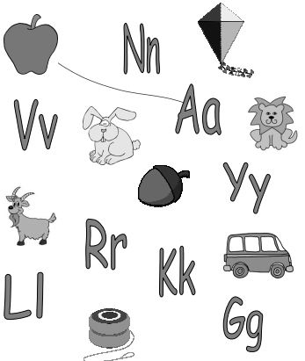
III. Draw a line from the picture to the letter.

