Name:…………………………………….
Class:………………………………………
WORKSHEET ENGLISH GRADE 3 – REVISION 3
I.Trace and write the missing letters
7 2 9 4 3
s_e_ v_e_ n t __ o n__ n__ f__ u__ t__ r__ e
8 0 5 6 1
e__ g__ t z __r __ f __v__ s __ x o__ e

II. Complete then write
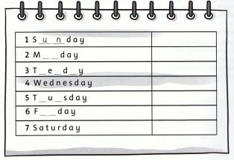
Sunday
III. Write
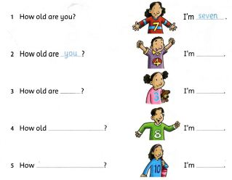

IV. Match
